Media Release

Nepal - Australia Joint Advisory Committee on Water Resource Management
The first Nepal-Australia Joint Advisory Committee (JAC) under a new Memorandum of Understanding on Water Resource Management took place on 23 November, 2023, in Kathmandu, Nepal.

Water and Energy Commission Secretariat’s Secretary Sushil Chandra Tiwari, together with Australia’s Ambassador to Nepal, HE Felicity Volk co-chaired the meeting. The JAC provides a platform for bilateral engagement in areas of mutual interest such as river basin planning and governance, the energy-water nexus, spring shed revitalisation, hydrometeorology, climate change, and disaster risk reduction.

The meeting endorsed a joint program of work that included the Kamala River Basin Action Plan; support for the Nepal Basin Information System; modelling of Pokhara and Tulsipur’s water sources to determine the efficient allocation of water for commercial and domestic-use; and a training package for federal and provincial officials on integrated river basin management, drawing on Australia’s experience in basin planning and management. The six-week training program is expected to start in January 2024.

JAC membership consisted of Director Generals from the departments of Electricity Development; Hydrology and Meteorology; Water Resources and Irrigation; along with representatives from Australia’s Commonwealth Scientific and Industrial Research Organisation, the Australian Centre for International Agricultural Research, and the International Centre for Integrated Mountain Development.

Australian experts, Dr Jane Doolan, Member of Australia’s Murray Darling Basin Authority and Mr Simon Krohn (Member, Australian Water Partnership) presented on Australia’s reform challenges in the water and energy sectors. They undertook a range of public engagements during the week, including a guest lecture at the Department of Water Resources Development, Institute of Engineering, a policy seminar with Independent Power Producers Association Nepal and Department of Electricity Development, and appearance podcast by PEI hosted by Policy Entrepreneurs Inc. (PEI).

4 December 2023
Media Contact:
Krishna.Karki@dfat.gov.au
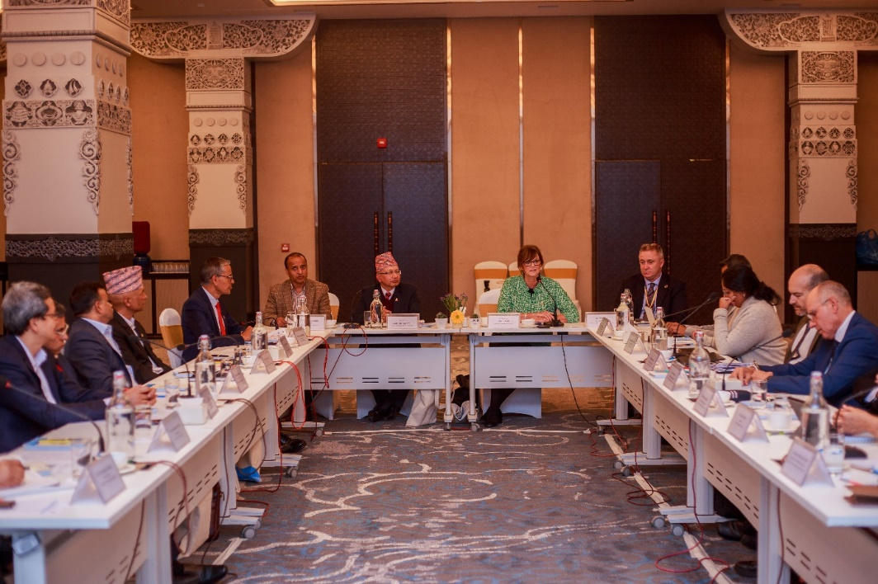
WEC Secretary Mr Sushil Chandra Tiwari, Australia’s Ambassador to Nepal HE Felicity Volk and other participants during the first Nepal-Australia Joint Advisory Committee (JAC) meeting under a new Memorandum of Understanding on Water Resource Management in Kathmandu on 23 November 2023.

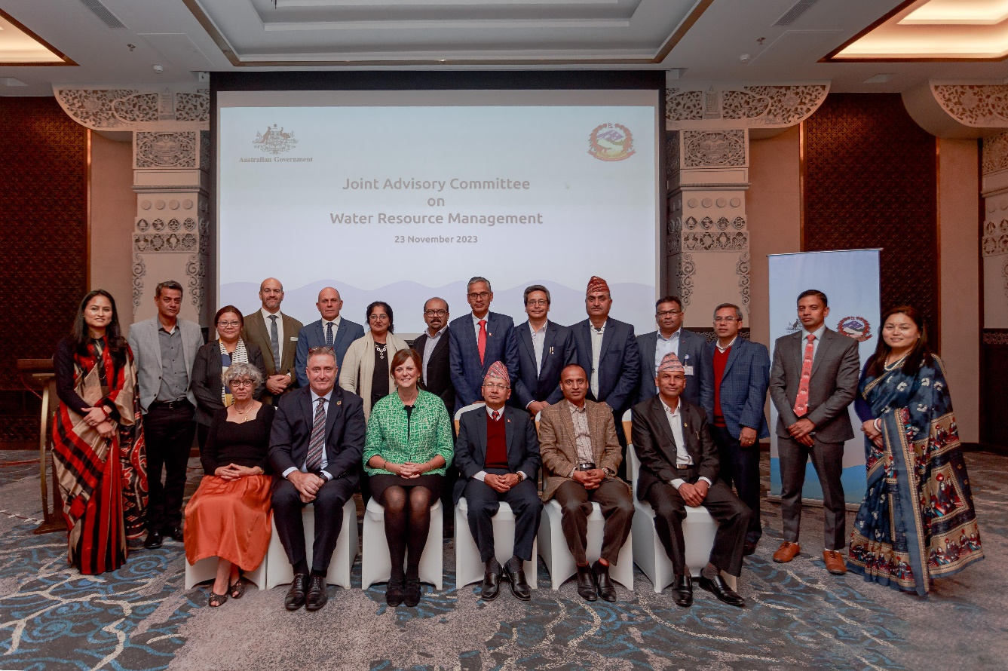
WEC Secretary Mr Sushil Chandra Tiwari, Australia’s Ambassador to Nepal HE Felicity Volk and other participants during the first Nepal-Australia Joint Advisory Committee (JAC) meeting under a new Memorandum of Understanding on Water Resource Management in Kathmandu on 23 November 2023.

